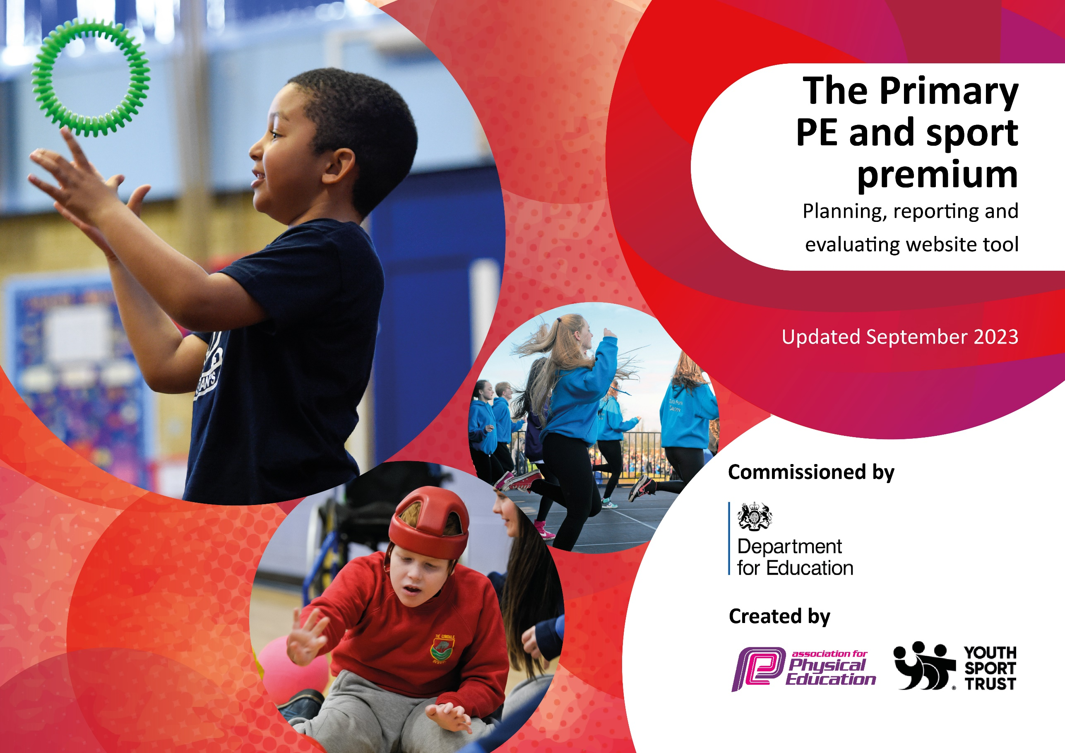

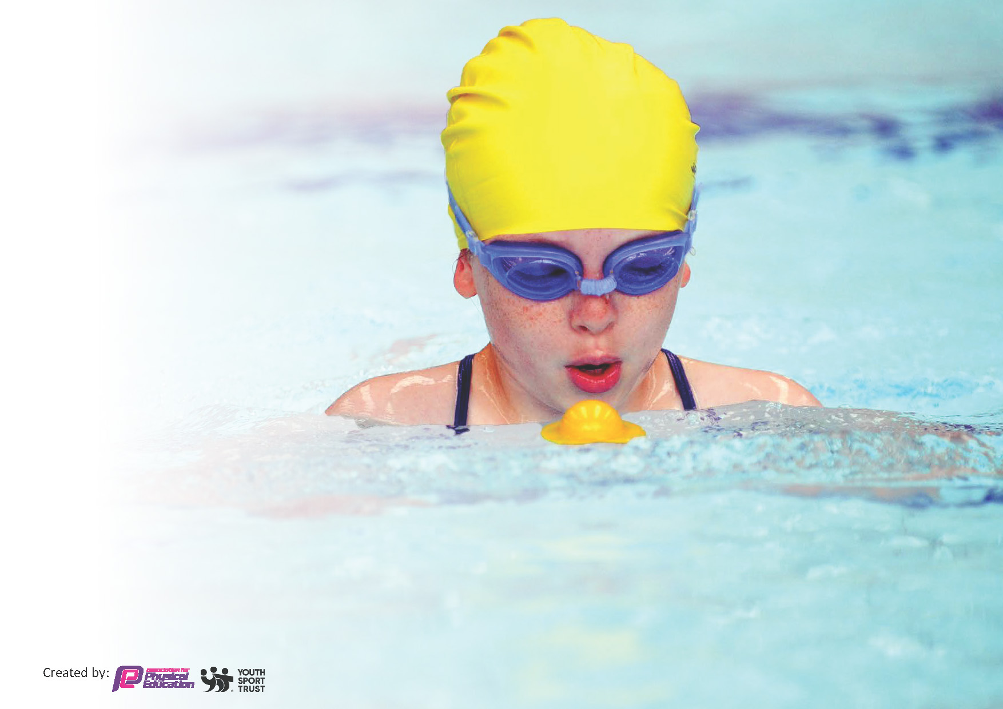
This template can be used for multiple purposes:
by:
- It enables schools to effectively plan their use of the Primary PE and sport premium
- It helps schools to meet the requirements (as set out in guidance) to publish information on their Primary PE and sport premium
- It will be an effective document to support Ofsted inspections enabling schools to evidence progress in Physical Education (PE) and evidence swimming attainment, which forms part of the PE National Curriculum. We would recommend schools consider
the Intent, Implementation and Impact of any spend, as examined within the Education Inspection Framework.

It is important that your grant is used effectively and based on school need.

Schools must use the funding to make additional and sustainable
improvements to the quality of the PE, School Sport and Physical Activity (PESSPA)
they offer. This means that you should use the Primary PE and sport premium to:

- Build capacity and capability within the school to ensure that improvements made now will benefit pupils joining the school in future years
- Develop or add to the PESSPA activities that your school already offers.

The Primary PE and sport premium should not be used to fund capital spend projects; the school’s core budget should fund these. Further detail on capital expenditure can be found in the updated Primary PE and sport premium guidance.

The Primary PE and sport premium guidance, outlines 5 key priorities that funding should be used towards. It is not

necessary that spending has to meet all the key priorities, you should select the priorities that you aim to use any funding towards.

Although completing this template is not a requirement for schools, schools are required to publish details of how they spend this funding. Schools must also outline what the impact this funding has had on pupils’ PE and sport participation and attainment and how any spending will be sustainable in the future. All funding must be spent by 31st July 2024.

The Department for Education has worked closely with the Association for Physical Education (afPE) and the Youth Sport Trust (YST) to develop this template and encourages schools to use it. This template is an effective way of meeting the reporting requirements of the Primary PE and sport premium.
Review of last year’s spend and key achievements (2022/2023)

We recommend you start by reflecting on the impact of current provision and reviewing your previous spend.

Activity/Action | Impact | Comments
Top up lessons for ALL ks2 children through the hiring of a pop up pool and swim coaches in Summer 2 (4 weeks) | Most children overcame their fear of water and became aware of water safety. Children had more time to develop their confidence and strokes. | Due to the success of the pop up pool in developing confidence and overcoming we have rented is for the whole Summer 2 term.
After school clubs based around fun activities such as Nerf Wars / Glow Dodgeball | More children attended compared to the competitive traditional sporting ASC thus working towards the 60 minute exercise target. | Continue these types of club to run alongside the more traditional sporting clubs (needed to build skills as well as fulfil exercise requirements).
Specialist sports coaches employed to deliver lessons and provide CPD for staff | Staff are more confident in delivering some of the sports | Continue with sports coaches in providing CPD for teachers (7 New members of staff for 2023/24)

Key priorities and Planning
This planning template will allow schools to accurately plan their spending.

Action – what are you planning to do | Who does this action impact? | Key indicator to meet | Impacts and how sustainability will be achieved? | Cost linked to the action
Arrange for CPD | All teaching staff | Key Indicator 1. Increased confidence, knowledge and skills of all staff in teaching PE and sport  Key indicator 5: Increased participation in competitive sport. | Children will develop skills and progress more quickly / children will become more engaged when PE are delivered by confident teachers. | £7000  Sports coaches
Provide opportunities for children to move and partake in sporting activities throughout the day including after school clubs | PE lead, Welfare staff and playground leaders, teachers / coaches running the ASC | Key indicator 2 -The engagement of all pupils in regular physical activity – the Chief Medical Officer guidelines recommend that all children and young people aged 5 to 18 engage in at least 60 minutes of physical activity per day, of which 30 minutes should be in school. | More pupils meeting their daily physical activity goal.  More pupils encouraged to take part in PE and Sporting Activities.  Children to develop skills and discover a love of sport which may be the catalyst to join a club | £3000  Resources and coaches
To provide opportunities for children to participate in competitive sport and non-competitive sport at an inter-school level. | Teaching and support staff to attend and supervise the children in extra curricular activities and events. | Key indicator 4: Broader experience of a range of sports and activities offered to all pupils.  Key indicator 5: Increased participation in competitive sport. | More pupils meeting their daily physical activity goal, more pupils encouraged to take part in PE and Sport Activities.  Healthier children involved in sporting activities creates a positive mindset and confidence  Children will experience competitive sport and are provided opportunities they wouldn’t normally have access to | £4000.  Membership of the local school sports partnership.  Transport to and from events. Resources such as equipment and kit.
Provide ‘Top up’ swim and water safety lessons | Pe lead to organize timetable | Key indicator 4: Broader experience of a range of sports and activities offered to all pupils. | Children are able to further familiarize themselves with being in water and are able to further develop strokes and their knowledge/practical skills in water safety. | £2500  Pop up Pool and Coaches

Key achievements 2023-2024
This template will be completed at the end of the academic year and will showcase the key achievements schools have made with their Primary PE and sport premium spending.

Activity/Action | Impact | Comments
Provide opportunities for children to move and partake in sporting activities throughout the day including after school clubs. | Many children now feeling the positive impact of participating in physical activities through the day. Children are able to explain they feel more ‘energised’. Some children are developing their FMS through repetition of these activities. Friendship groups are being formed through the common interest. Children are developing an understand of the importance of movement and activity. | Although an improvement it is still early days.  Low participation on ASC due to Mosque. Need more clubs before / during school.  Friday football for Years 5/6 a success in terms of numbers.  Daily mile helping those inactive children to become active.
To provide opportunities for children to participate in competitive sport and non-competitive sport at an inter-school level. | Those children who competed in intra / inter competition felt proud to represent school and it gave them a glimpse into organized sport outside of school – 3 boys have gone on to join a grass roots football team. | Early days: we need to participate in more events!  Struggled with staffing to drive to and supervise children at after school events.  Limited number of children due to mosque.  Limited availability of TA’s throughout the day.
CPD for teachers | Teachers feedback that they felt more confident in delivering PE lessons, especially dance and gymnastics. | Amount of time teachers could spend with PE specialist was limited because of PPA time.

Swimming Data
Meeting National Curriculum requirements for swimming and water safety.
Priority should always be given to ensuring that pupils can perform safe self-rescue even if they do not fully meet the first two requirements of the National Curriculum programme of study

Question | Stats: | Further context  Relative to local challenges
What percentage of your current Year 6 cohort can swim competently, confidently and proficiently over a distance of at least 25 metres? | 0% | Culturally our children are not familiar with water and are often frightened of entering.  Last year we invested in top up lessons for all our KS2 children - so this year we may see a slight improvement
What percentage of your current Year 6 cohort can use a range of strokes effectively [for example, front crawl, backstroke, and breaststroke]? | 0% | The majority of our children can crawl for around 10 metres

What percentage of your current Year 6 cohort are able to perform safe self-rescue in different water-based situations? | 0% | Our children are becoming more familiar with water and the danger it presents. Again the fear of the water hinders any progress.
If your schools swimming data is below national expectation, you can choose to use the Primary PE and sport premium to provide additional top-up sessions for those pupils that did not meet National Curriculum  requirements after the completion of core lessons. Have you done this? | Yes
Have you provided CPD to improve the knowledge and confidence of staff to be able to teach swimming and water safety? | No | We hire qualified swim coaches

Signed off by:

Head Teacher: | (Name)
Subject Leader or the individual responsible for the Primary PE and sport premium: | Jonathan Hill
Governor: | (Name and Role)
Date: | 18.07.24

