Policy for Teaching and Learning
including Feedback and Marking Policy
September 2023

Introduction
At Spring Hill, learning is a rewarding and enjoyable experience for everyone. The school values: Responsibility, Aspirational, Inclusivity, Service, and Empowerment are the characteristics that we aim to foster in our children everyday through our teaching and learning practice. Learning is a change to long term memory and through our teaching we equip children with the skills, knowledge and understanding necessary to enable them to maximise their potential and equip them with the necessary life skills and attributes they need for an ever-changing world. We make learning sticky so our children are skilled in retrieving, shaping and utilising what we have taught them.
Within this policy the term ‘all children’ refers to every child who attends the school including and not limited to: age, gender, special educational need, disability, race including colour, nationality, ethnic or national origin, religion or belief. Likewise, within this policy the term parent refers to the person or peoples who have parental responsibility for a child.
Aims and objectives
Through our teaching and learning activities:
- We want children to develop an appetite and aptitude for learning that will stay with them for the rest of their lives.
- We want children to enjoy learning and relish the challenge of mastering new skills and knowledge.
- We want children to develop lifelong skills in developing successful learning strategies for themselves.
- We want every child to look back positively on their school experience having achieved the highest standard of work and achievement.
- We will use research based approaches in our teaching and adapt, refine and improve our teaching approaches utilising the best evidence.
- We will adopt approaches in our classrooms which help children integrate new knowledge into the long term memory.
- We will provide learning experiences and opportunities which create awe and wonder and develop a love of learning – leading to lifelong learners.
- We will foster and develop a vibrant and self-improving teaching and learning community where teachers engage with CPD and utilise this to have maximum impact on the children’s learning.
Responsibilities
Teaching and learning in our school is a shared responsibility, and everyone in our school community has an important role to play.
Teachers at our school will:
- Prioritise developing relationships with both children and parents to ensure effective learning can take place.
- Follow the expectations for teaching and professional conduct as set out in the Teachers’ Standards.
- Follow the expectations as set out in this policy.
- Update parents/carers on children’ progress through termly reports on progress and parent/carer evenings.
Support staff at our school will:
- Know children well and adapt their teaching to meet their individual learning needs.
- Support teaching and learning with flexibility and resourcefulness.
- Meet the expectations set out in this policy.

Subject Leaders will:
- Help to create a well-sequenced, broad and balanced curriculum that builds knowledge and skills.
- Sequence lessons in a way that allows all children to make good progress.
- Drive improvement in their subject.
- Improve on development areas identified in their monitoring activities.
- Create and share clear intentions for their subject.
- Encourage teachers to share ideas, resources and good practice.
- Provide a range of strategies and resources to enable all children to achieve.
Senior leaders at our school will:
- Have a clear and ambitious vision for providing high-quality, inclusive education to all.
- Celebrate achievement and have high expectations for everyone.
- Plan and evaluate strategies to secure high-quality teaching and learning across school.
- Manage resources to support high-quality teaching and learning.
- Provide support and guidance to other staff through coaching and mentoring.
- Promote team working at all levels.
- Provide research based CPD for teaching staff.

Children at our school will:
- Take responsibility for their own learning, and support the learning of others.
- Meet expectations for good behaviour for learning at all times.
- Attend all lessons on time and be ready to learn.
- Be curious, ambitious, engaged and confident learners.
- Put maximum effort and focus into their work.
- Complete home learning activities as required.

Parents and carers of children at our school will:
- Value learning and encourage their child as a learner.
- Make sure their child is ready and able to learn every day.
- Support good attendance.
- Participate in discussions about their child’s progress and attainment.
- Communicate with the class teacher in the first instance to share information promptly.
- Encourage their child to take responsibility for their own learning.
- Support and give importance to home learning.

Governors at our school will:
- Monitor that resources and funding are allocated effectively to support the school’s approach to teaching and learning.
- Monitor the impact of teaching and learning strategies on children’s progress.
- Monitor the effectiveness of this policy and hold the headteacher to account for its implementation.

Planning
‘Planning is a process not a product. It has one purpose; to enable high quality delivery which enables all children to learn.’
All teachers need to be clear and precise about the knowledge/skills they want children to learn in every lesson.
Teachers should spend time thinking about what they want children to learn first before they give consideration to what they want them to do.
The questions teachers need to ask when planning a lesson are:
1. Where are the children starting from?
2. Where do you want them to get to?
3. How will you know when they are there?
4. How can you best help them get there?
Intended Learning
It is important that the teacher, children and support staff are all clear about the key learning that will take place in a lesson.
Teachers should make the intended learning for the lesson explicit to children. All children should be able to explain what the key learning of the lesson is.

Long term planning
At Spring Hill, our learning is broken down in to curriculum milestones which provide coverage of the Primary National Curriculum. Milestones are progressive and inform the sequence of learning to be planned and delivered. Children will build on existing knowledge as they progress through school. Teachers are aware of the milestones to be taught prior to and following the year group they teach. Whilst subject leaders are aware of the milestones to be taught across all year groups. The foundation subjects are planned carefully within a school year to allow for links between learning to be made and to build on prior knowledge.
Short term planning
Short term planning begins with the intended learning. Teachers plan review tasks to begin lessons to activate prior knowledge. When planning, teachers identify when previous curriculum links have been taught and carefully plan to build on this knowledge, as well as being aware of the future knowledge children will gain in the next year or key stage. Short term planning identifies key questions, vocabulary to be taught and teaching strategies to be used to help deliver each lesson.
Planning to meet the needs of all children
Knowledge of the children; their prior attainment and specific needs, is a key part of planning.
Teachers are expected to know the profile of the children they teach. High quality teaching is the first wave of intervention for meeting the needs of SEND children. Adaptations should be planned over time to ensure a high quality approach which meets the needs of all children and groups and maximises the use of any additional adults in the room. When planning, teachers should consider the different pedagogical approaches used to engage, motivate and challenge all learners.
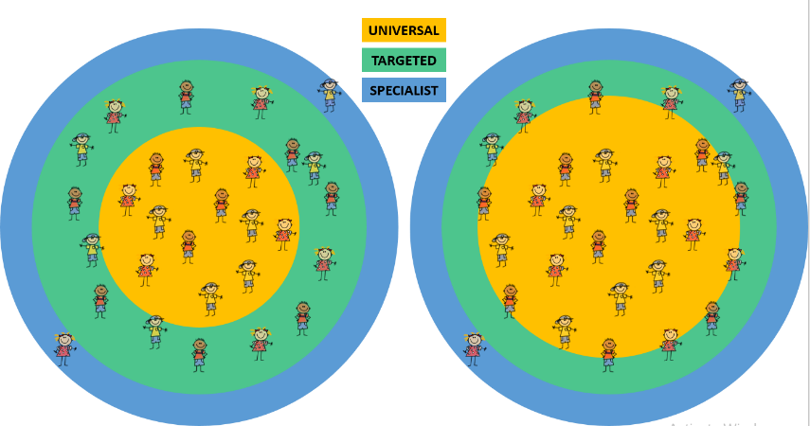

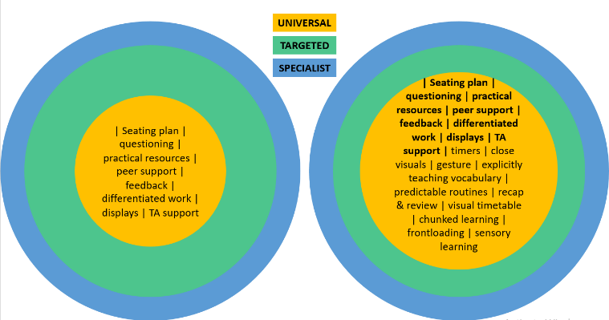

Our lessons are planned to include all learners. What is in place for one child, is accessible for all children in the class. Our universal teaching approach uses high quality teaching strategies as wave one. The diagram demonstrates our approach to learning and teaching for all children.

Teaching
“Every teacher needs to improve, not because they are not good enough, but because they can be even better.” (Professor Dylan Wiliam)
Teachers must be explicit about the key knowledge and vocabulary that all children must use. Children must know the knowledge and key skills they are required to learn and the language they are expected to understand and use.
We are all teachers of literacy; the quality of both children’s and teachers’ language, through instructions and questioning, are significant determinants of progress.

High quality teaching strategies
What a “typical lesson” will look like will vary from subject to subject and teachers may utilise a variety of strategies based upon their professional judgement and knowledge. However, it is expected that the agreed high-quality teaching strategies are used effectively in the majority of lessons. (See Appendix A)
Challenge
We should have high expectations of all children all of the time. It is good for children to struggle just outside of their comfort zone. All children must be working harder than the teacher over time and should begin learning as soon as they arrive in the classroom and for the whole lesson.
Explanation
Teacher instruction should be planned with awareness of demands on children’s cognitive load, by presenting new material in small steps.
1. Limit the amount of material children receive at one time.
2. Give clear and simple instructions and explanations.
3. Think aloud and model steps.
4. Use more time to provide explanation and provide many examples.
5. Re-teach as necessary.
Vocabulary
Vocabulary for English and Maths is displayed next to the working wall and changed daily or added to as the unit progresses. This vocabulary is modelled during the ‘I do’ section and the children will then apply this to their own learning during the ‘we do’ and ‘you do’ stages of the learning process. Vocabulary will be revisited throughout each lesson and as part of the prior learning assessment section of each lesson.
Modelling (I do)
Teaching with clear instruction and modelling. To learn how to do something, children need to watch, listen and engage with teachers who will guide them through the process, step by step, before they make an attempt themselves. This learning will be separated into manageable chunks to avoid cognitive overload.
Modelling supports explanation and can help children to make abstract ideas concrete. E.g.
1. Demonstrate the activity in front of children using modelled examples
2. Think aloud to show the thought process.
3. Show it is ok to make mistakes.
4. No questions are asked at this point in teaching.

Guided practice with scaffolding (we do)
Worked examples of tasks and scaffolding are used to support all children to aid with their learning e.g. sentence starters, key word definitions etc. Effective class discussion and questioning will happen at this stage, as well as partner, group and class collaboration. Limited, selective questioning should be integrated to help further progress children’s understanding at this point of learning.
Independent practice (you do)
Children should be provided with the time they need to practise new material in a number of ways in order to master it. At this point, scaffolding may be reduced. Task should be ideally just outside of children’s comfort zone. Teachers have an understanding of the learning pit (James Nottingham) and the suitable challenge and scaffolding which needs to be within each lesson.

What this looks like at Spring Hill Primary School
I do (modelling)
Children face the direction of the teacher
Children use cinema seats if they are in the classroom (turn their chairs face the front of the classroom)
Children are silent and have their hands free
Children watch the clear modelling of the teacher without asking questions
The teacher models the example, thinking out loud.
No questioning will happen at this point in teaching
Teaching assistants support the needs of identified children in class to aid the learning and ensure the content being modelled is accessible. Teaching assistant to prompt the teacher if they feel that modelling is unclear or further clarity is required. Teaching assistants may also model thinking alongside teachers, for example when addressing misconceptions.

We do (guided practice)
Children will work independently, in pairs or in small groups to solve a question similar to that modelled in the ‘I do’ section
Children will discuss their learning and thinking processes with their peers
Children will have the opportunity to ask questions
The teacher will use selective directed questions at this point as a means of AFL and to further children’s understanding
Children will feedback their thoughts, answers and ideas, sharing them with the class
Children could use sentence stems at this point to relay their answers
The teacher will model again, this time encouraging explanations and using questioning
Children will face the teacher using cinema seats (if in the classroom) to watch the second modelling
Teaching assistants will be directed by the teacher as to who to work with at this point in the lesson. They will guide these children and then move away to allow for independent work when necessary
You do (independent practice)
Children will work independently or in pairs, dependant on task
Children may discuss their learning with their peers
Children can ask for further support from the teacher/ teaching assistants
The teacher will assess children’s understanding at this point, circulating the room or targeting specific individuals
Teaching assistants will be directed by the teacher as to who to work with at this point in the lesson. They will guide these children and then move away to allow for independent work when necessary

Classroom signals
All staff will use the agreed non-verbal school signals.
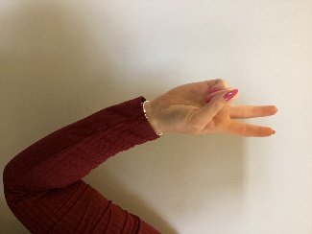 1,2,3 (1 stand, 2 move, 3 sit)

TTYP- talk to your partner

Stop signal (hand raised and no words spoken until all hands are up and the room is silent)

Responsive Teaching
Teachers should ensure that learning has ‘stuck’, by checking for understanding during the lesson and through review activities in future learning. All teachers should confidently and accurately use teaching techniques to gather a secure overview about whether the key learning has actually been learned. Teachers should be aware of the simple model of memory when planning and delivering lessons, ensuring the knowledge needed to access the new learning is securely in the long term memory. Teachers will plan for retrieval tasks to stimulate prior knowledge as an assessment tool, before commencing with the new learning for the lesson. If learning is not yet secure for children, same day intervention should address misconceptions before the next lesson in the sequence is taught.
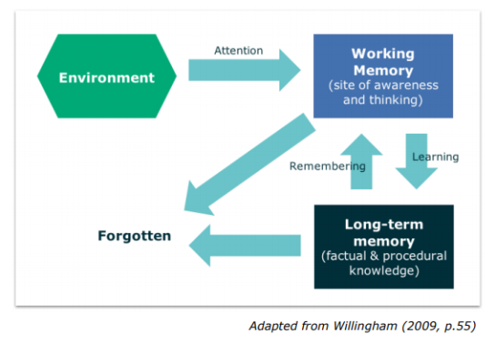
For responsive teaching teachers can use:
Questioning
Effective teachers ask a large number of questions skilfully, as questioning is our main tool to check and extend children’s understanding. (The ways in which teachers ask these questions is found in Appendix B)
Teachers should ask questions, to lots of children, and then use what they learn from this process to adapt and reshape teaching within and between lessons. Teachers understand the importance of allowing thinking time for all children and build this in to their planning.
Use effective feedback (See Appendix C feedback and marking policy)
Marking and assessment have two purposes.
1. It allows children to receive feedback which they act on to make progress over time.
2. It informs a teacher’s future planning and teaching.
Marking should:
- Feedback should be timely and respond to the need of the individual learner so that they can actively engage with the feedback
- A dialogue should be created: between the teacher and child, between the child at large, or between the child and themselves. It is essential to allow time for children to engage with feedback and enact that which they feel is relevant and important to moving their learning forward.
- Peer and self-feedback are valuable tools for learning that should occur regularly, after careful structuring by the teacher.

The Learning Environment
In order for there to be excellent learning behaviour, there needs to be the right classroom conditions; where all children feel safe, supported and valued. To ensure all children are confident in knowing what is expected of them in terms of work and behaviour, all teachers are expected to have:
High expectations – teachers should always have high expectations for learning and behaviour for all their children
• Provide scaffolds to support those who need it. Working walls are updated daily, with modelled examples of current learning, for children to refer to as scaffolds.
• Promote active engagement.
• Believe all children are able to achieve.
Teachers build positive relationships with all children through positive behaviour management, modelling the school vision and values:
- Recognise children demonstrating our school values of: Responsibility, Aspirational, Inspirational, Service, Empowerment
- Welcome all children into class by greeting them at the door.
- Create pupil profiles for those children who require extra provision to access the learning environment.
- Use praise and positive recognition through the Above and Beyond awards.
Teachers have clear and consistent routines and procedures– so there is a safe, orderly learning environment and learning time is maximised
• Title is shared on the board from the very start of every lesson – learning begins immediately, every minute matters.
• Have a classroom agreement which is fair and reasonable, so that all children know exactly what is expected of them when they enter their classroom.
Monitoring and Evaluation of Teaching and Learning
We will monitor teaching and learning across the school to make sure that all our children make the best possible progress from their starting points
Aims of monitoring and evaluation:
• To make secure judgements of teaching and learning across the school.
• To monitor and evaluate the progress of children.
• To identify training needs across the teaching and support staff and drive CPD.
SLT and subject leaders will monitor and evaluate the impact of teaching on student’s learning through:
• Conducting learning walks.
• Book looks.
• Review of termly progress checks.
• Gathering input from student voice and teacher questionnaires.

Continuing Professional Development
“Be the best you can until you know better, and when you know better, do better and be better”. Maya Angelou
All staff at Spring Hill should engage with high quality, researched based CPD and be open minded, reflective and proactive at continually trying to improve their teaching practice.
Teaching and Learning CPD will be focused around what will have the biggest impact on developing teachers and outcomes for children. The aim is to ensure all CPD is embedded, reviewed and evaluated.
CPD at Spring Hill is:
• Focused on High Quality Teaching.
- Research based.

Appendix A
High quality teaching strategies
Fan-N-Pick
Child 1 hold questions in a fan and says ‘’Pick a card, any card’
Child 2 picks a card, reads it aloud and allows for 5 seconds of thinking time.
Child 3 answers the question
Child 4 responds to the question through either identifying right and wrong or paraphrasing and praising
Children rotate roles one turn clockwise.
Carousel feedback
Teams stand in front of their projects
Teams rotate clockwise to another project
For a set amount of time they discuss their reactions to the other teams project but do not write anything.
Child one records the positive feedback.
Teacher calls time to move on.
Children rotate again with a new scribe this time,
Teams continue to rotate until they are back at their own project and they then reflect on the feedback given.
Find someone who
Children mix in the class, keeping their hand raised until they find a partner who is not a team mate.
In pairs, partner A asks a question. Partner B responds. Partner A writes down their answer and thanks them for their contribution
Partner B checks and initials the answer.
Partner B asks a question. Partner A responds. Partner B writes down their answer and thanks them for their contribution
Partner A checks and initials the answer.
Partners shakes hands, part and raise a hand looking for a new partner.
Continue until the worksheet is complete.
Children sit down but can still be used as a resource for others.
As a team, compare answers. If there is a disagreement or uncertainty, all 4 team members raise their hands to ask a group question.

Find-the-fiction
Children write 3 statements. Two true and one false, attempting to trick their team mates.
One child stands and reads their statements to their team mates.
Without any consulting, each team mate writes down their thought on which statements is false.
Team mates round robin and defend their guess. Teachers may ask them to arrive at a consensus.
Team mates announce their guess.
The standing child announces their false statement.
Children celebrate: children who were fooled congratulate the standing child and the standing child congratulates those who guess correctly.
The next team mate stands and the process is repeated.
Jot Thoughts
Teacher poses a question with multiple answers and sets a time limit.
Children announce their answer to their team mates and jot their answer on a slip of paper. One idea per paper.
Paper slips are put in the centre of the table. Children attempt to cover the table with different answers, without overlapping the paper.
Inside-outside circle
Children form pairs.
One partner forms an inner circle facing the outside of the room. The other partner stands facing them, facing the inside of the room. Two concentric circles should now be formed.
Teacher poses a questions. Inside partner answers to their partner. Partner listens.
Children then swap roles and the outer partner answers.
Children on the outside then move a set amount of spaces, directed by the teacher, clockwise to gain a new partner.
Repeat above.
Teacher shouts ‘swap’ and children switch places with their current partner.
Mix-Pair-Share
Children mix around the room until teacher calls ‘pair’.
Children pair up with the closest person to them.
Teacher poses a questions and allows for thinking time.
Children share their answers with their partner using rally robin or timed pair share.

Numbered heads together
Children decide on their number within their group.
Teacher poses a question and allows for thinking time.
Children privately write their answer down.
Children stand and share answers, teach each other or show answers. Children to sit down when they have come to a consensus.
Teacher calls a number and that person feeds back their groups decision.
One stray
Children work in a group with their team mates.
Teacher calls a number and that number from each group stands up and the other team mates raise their hand.
Teacher calls stray and that child leaves the group to find another group.
Team mates lower their hands when a new team mate joins tham. They continue to work in new teams.
Quiz-Quiz Trade
Teacher prepares question cards or the child develops their own.
Teacher calls stand up, hand up, pair up.
Partner A quizzes B and partner B answers.
Partner A then praises or coaches partner B.
Partners switch roles.
Partners trade question cards and thank each other.
Repeat a number of times with new partners.
Rally Coach
Each pair needs a set of high consensus questions.
Partner A solves the first problem.
Partner B watches, listens, checks and coaches if necessary.
Partner B solves the next problem.
Partner A watches, listens, checks and coaches if necessary.
Partners repeat taking turns.

Round Robin (table group) and Rally Robin (with partner)
Teacher poses and question to which there are multiple answers.
Children take it in turns to give an answer.
- All Write Round Robin- children each record each other’s answer on paper.
- Think-write Round Robin- children independently think and write down their answer before starting the round robin.
- Timed Round Robin- each child gives their answer for a set amount of time I the round robin.
Round Table
Teacher provides a question to which there are multiple answers
Children take it in turns to write their answer then pass on the paper and pencil, with all children making a contribution.
Simultaneous Round table
As above but all children have their own paper and pencil.
Children write their response on their paper. Thumbs up when complete.
Pass their paper clockwise to the next person who then contributes.
Spend a buck
Options to be voted on are laid on the table on separate slips of paper.
Children have 10 chips each. They can vote for their favourite by placing their chips on their preferred option.
The option with the highest amount of coins will win.
Stand up- hand up- pair up
Teacher instructs children to move on a command with their hand in the air.
Children find the closest partner who is not a team mate. Give each other a high five and put their hands down.
Teacher asks a question or instruction
Partners interact using rally robin or timed pair share.
Talking chips
Teacher provides a topic or question and allows thinking time.
Any child begins the discussion and places their chip in the middle of the table.
Any child with a chip can then contribute, putting their chip in the middle of the table.
When all team mates chips are in the middle, children can reclaim their chips and the conversation can continue.

Timed Pair Share
Teacher announces the topic or question, the amount of time each partner will have and allows thinking time.
In pairs, partner A shares and partner B listens.
Partner B responds with a positive.
Switch roles and repeat.

Appendix B
Questioning techniques
- Lollypop sticks​
- Pose, Pause, Pounce, Bounce​
- Timed Pair Share / Think Pair Share – What did your partner say?​
- Mini Whiteboards​
- Random pupil selectors
- Mexican wave
- Popcorn retrieval

Appendix C
Feedback and marking policy
Spring Hill Community Primary School
Feedback and Marking Policy

What is Feedback?

We acknowledge that feedback comes in a variety of forms and should be a regular and robust part of every lesson. Feedback, as an integral part of the learning process, must be precisely positioned and delivered regularly in each aspect of the lesson. All feedback should have a positive tone. It should be specific, clear and appropriate in its purpose and productive in its outcomes. The best feedback, whether it is written or verbal, will give children a clear sense of how they can improve, with children responding and making progress as a result.

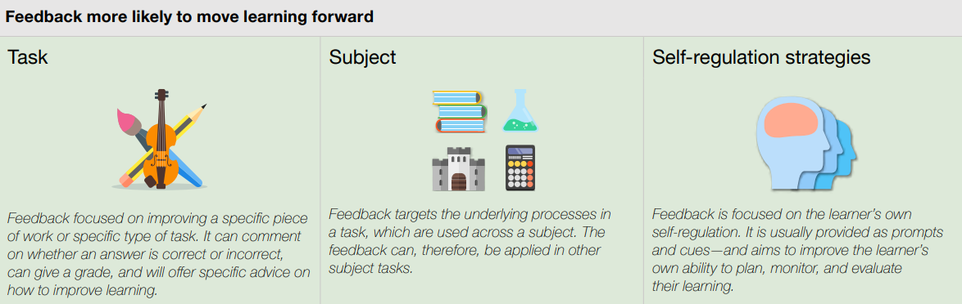
This table is reproduced from recommendation 2 in the EEF guidance report: Teacher Feedback to Improve Children Learning

Aims of Feedback and Marking

- To help children make progress
- To provide strategies for children to improve
- To give children dedicated time to reflect upon their learning and put effort in to make improvements
- To inform planning and structure the next phase of learning
- To facilitate effective and realistic target setting for children and/or the teacher
- To encourage a dialogue to develop between children and teacher
- To encourage children to have a sense of pride in their work
- To encourage childrens to perfect presentation
- To correct mistakes with a focus on English and mathematics skills and strategies
Principles of Feedback and Marking

- Feedback should be timely and respond to the need of the individual learner so that they can actively engage with the feedback
- A dialogue should be created: between the teacher and child, between the child at large, or between the child and themselves. It is essential to allow time for children to engage with feedback and enact that which they feel is relevant and important to moving their learning forward.
- Peer and self-feedback are valuable tools for learning that should occur regularly, after careful structuring by the teacher.

Type and Frequency of Feedback and Marking
Verbal Feedback
- This is the most frequent form of feedback.
- It has immediacy and relevance as it leads to direct pupil action.
- Verbal feedback may well be directed to individuals or groups of children; these may or may not be planned for, but will be based on acute and strategic assessment for learning.
Peer Feedback
- This is shown by research to be one of the most effective modes of feedback. Effective peer feedback is structured and modelled by the teacher.
- Childrens need to be well trained over time to effectively peer assess one another. This process will be led by all teachers.
Self Reflection, Assessment & Feedback
- As with peer feedback, children need an explicit and clear structure to identify their learning needs.
- Teachers should both help uncover and share the elements of success in learning where appropriate.
Marking
- All work is acknowledged using the school Marking Code (Appendix A).
- Work is presented in line with the Presentation Agreement (Appendix B).
- Written feedback will model all aspects of our presentation/handwriting expectations
- When determined appropriate to use, written feedback will provide clear actionable ideas to improve their work.
- This may include identifying specific issues such as key words, presentation issues, spellings, etc.; children should act upon these.

Appendix A – Marking Code
All books:
Teachers mark using two colours: pink to acknowledge where work meets the learning objective and green to move the learning on. Titles are highlighted in pink or green for every piece of work. This may take various forms, including:
Summative feedback/marking
This usually consists of ticks or a mark signifying incorrect work and is associated with closed tasks or exercises. Where ever possible children should self mark or the work should be marked as a class or in groups.
Formative feedback/marking
With oral feedback, in the course of a lesson, teachers’ comments to children should focus on issues about the intended learning and secondly on other features. When verbal feedback is given the work should be marked with VF and a short comment. E.g. VF – full stops
Quality marking
Not all pieces of work can be ‘quality marked’. Teachers need to decide whether work will simply be acknowledged using the drafting code or given detailed attention through deep marking. Over the course of a week, there should be deep marking of at least two pieces of writing and at least one opportunity for children to peer/self-assess. There should also be deep marking of at least one other subject (not Maths) per week.
Teachers should avoid general, non-specific feedback. The emphasis in marking should be on improvement needs. Highlighting the title/intended learning allows children to understand if they have been successful. Focused comments should help the child in ‘closing the gap’ between what they have achieved and what their next step is. E.g. For the underlined section, can you think of a simile? Deep marking includes the use of the drafting code as well as a next step or ‘closing the gap’ comment that will improve the quality of work.
Closing The Gap Prompts:
- Reminder prompt – the simplest form of prompt and refers back to the intended learning

e.g. Use adverbial starters.

- Scaffold prompt – provides further support. This may take the form of a question or a short cloze procedure

e.g. Add a simile to the postman’s journey through town

- Example prompt – this is the most detailed support and gives children examples from which to choose

e.g. The man, whose feet reminded Paul of planks of wood, stood watching out over sea.
Underline the relative clause and use this in your writing.

Secretarial features
Spelling, punctuation, grammar etc. should not be asked for in every piece of narrative writing, because children cannot effectively focus on too many things in one space of time. When work is finished ask children to check for things they know are wrong in their work when they read it through. They should not be told to correct all spellings, or they are likely to write further misspellings or waste time looking words up.
Self Marking
- Children should self- evaluate wherever possible using the drafting code. Children can identify their own successes (one/two or three) and look for improvement points.
Peer Assessment
Can be class/group or pairs
Children should sometimes be asked to mark narrative work in pairs. The following points are important:
- Peer assessment should not be introduced until Key Stage 2, unless teachers feel younger children are ready for this.
- Peer assessment should form part of the editing sequence of lessons.
- Children need to be trained to do this, through modelling with the whole class, watching the peer assessment in action.
- Encourage a dialogue between the children rather than taking turns to be the ‘teacher’: they should discuss each other’s work together (e.g. I think this bit really shows how the character feels, what do you think?)

General Principles - Maths

Teachers will:
- Always address incorrect work. This may be done through: corrections, oral feedback given or comments to feedback on. This may also at times be addressed in subsequent lessons (repetition of the intended learning) to address misconceptions.
- Always provide children with time to respond to feedback.
- Give ‘next steps’ to help to push children’s thinking forward when needed.
- Use feedback to push children’s reasoning and communication about mathematical ideas

Drafting / Marking Code

This should be displayed in all classrooms. Teachers and Teaching Assistants should use the codes as a guide to ensure consistency when marking children’s work and should be used by children when self and peer assessing and when proof-reading and editing their work.

A range of strategies / approaches should be used to ensure children receive high quality feedback at the point of learning.

Marking Code KS1 (SEND)

(Sp) - Indicates there is a spelling mistake. You must write the correct spelling 3 times when responding. No more than 3 spellings will be identified in a piece of work.
accrington - A circle indicates missing punctuation
↑ There is a word missing
← Writing should start near the margin
_____ Use an alternative word
Check the sentence/phrase (a wobbly sentence)
VF – verbal feedback. There has been verbal dialogue about the work between the child and the teacher, adult to initial. It is advisable to add a word or short comment to explain the focus of the dialogue so that improvement can be checked.
I – independent work completed by the child
S – support given
G – guided group work
Teacher highlights the title PINK if the intended learning has been achieved.
Teacher marks successes in PINK.
Teachers' written feedback is given in GREEN TAs' written feedback is given in GREEN.
Anyone marking work other than the class teacher must initial the work they have marked.
Stamps, stickers and smiley faces may be used to encourage, acknowledge good work and learning intention achieved.

Marking Codes – KS 2

(Sp) - Indicates there is a spelling mistake. You must write the correct spelling 3 times when responding. No more than 3 spellings will be identified in a piece of work.
accrington - A circle indicates missing punctuation
↑ There is a word missing
← Writing should start near the margin
_____ Use an alternative word
Check the sentence/phrase (a wobbly sentence)
VF – verbal feedback. There has been verbal dialogue about the work between the child and the teacher, adult to initial. It is advisable to add a word or short comment to explain the focus of the dialogue so that improvement can be checked.
I – independent work completed by the child
S – support given
G – guided group work
Teacher highlights the title PINK if the intended learning has been achieved.
Teacher marks successes in PINK.
Teachers' written feedback is given in GREEN TAs' written feedback is given in GREEN.
Anyone marking work other than the class teacher must initial the work they have marked.
Self/Peer marking to be recorded in PURPLE.
Anyone marking work other than the class teacher must initial the work they have marked

Appendix B – Presentation Agreement
Staff will:
- Teach children the skills required for presenting work.
- Encourage children to take pride in their work.
- Remind children regularly of expected standards.
- Use the guidance flexibly for children with SEND.
- Acknowledge and reward children’s efforts.
- Set high standards of presenting work for children in displays and classroom organisation.

The following information sets out clear guidelines on the expected presentation of work.
- All children’s work books have their name, subject and class on the front. Teachers write the children’s name following the school handwriting policy.
- Each piece of work must be dated on the left. As a model for this the teacher must write the date on the board. The short version of the date, with “dots”, i.e. 24.03.23 is to be used in all subjects with the exception of English books when the long version is used. The date should be underlined using a ruler.
- Each piece of work should have a title modelled on the board by the teacher. This may be the learning objective or a summary title for the task e.g. Fractions and should be started on the left hand side and underlined using a ruler. In EYFS and KS1, the title may be printed onto a label and stuck neatly into children’s books by an adult / child if they are able to do so. By the end of the Year 2 children will write their own date and title.
- If a new piece of work is to be continued on the same page, the end of the previous work must be clearly shown by a line drawn across the page under any previous writing, including any teacher’s comments.
- Any mistakes should be crossed out neatly using one ruled line. The correct version should be written on the same line or above the mistake, wherever is most appropriate.
- Tippex is not allowed.
- Rubbers are not permitted and should be used sparingly in exceptional circumstances. The use of pen or pencil is determined by the guidelines set out above.
- Other than for editing purposes, only blue pens may be used in exercise books. School handwriting pens only should be used.
- Felt tip pens and gel pens should not be used in any exercise books. Colouring pencils only should be used to colour in (if appropriate).
- A child must not write or draw ANYTHING on the covers of any exercise books.
- A child must not ‘doodle’ or in any other way mark any of the pages in their exercise books or on the cover.
- Drawings or diagrams must be done in pencil and straight lines drawn with a ruler unless it is intended to be a rough sketch. If a plain page is needed, this must be trimmed before being neatly stuck in.
- If appropriate, worksheets may be used in books – but should not protrude beyond the edges of the book. Folded over sheets should be glued into books neatly with no edges protruding beyond the pages of the book. Date and Titles should still be clear, following the above guidelines.
- When marking, handwriting MUST be in line with the school’s cursive script handwriting approach and must be neat and legible so as to set high expectations for the children.
- Any errors in presentation MUST be addressed by the teacher – through comments in the marking or through verbal feedback. Amendments to expectations for individual children may be necessary.
- In all subjects, with the exception of mathematics and English, a ‘topic page’, which includes a picture, topic title and unit number is stuck in to identify when new topics begin.

Mathematics
- Mathematical work is to be recorded in pencil.
- All lines should be drawn with a ruler; this includes answer lines for vertical calculations, tables, graphs and all straight sided shapes.
- For those children using squared pages, each digit should be written in a separate box to assist with understanding place value.
- All question numbers should be noted and shown by a bracket, e.g. 2) as dots can be confused with decimal points.
- Any corrections should be written out again as a new calculation rather than being altered on the original calculation.

Science
- Rulers must be used for any diagrams that need straight sides represented.
- All diagrams and lines to label parts must be drawn in pencil but written labels can be written in ink if appropriate.

Monitoring presentation throughout the school
- Presentation will be monitored through book and planning scrutinies throughout school and findings will be communicated back to staff.
- Random book collection will be undertaken by the SLT to focus on presentation (in addition to other aspects).
- Subject Leaders will monitor books for presentation and ensure that the quality of presentation is of the same standard as that in English and mathematics.

